**Tenant Data Energy Challenge Submission Content**

Tina Dong

[Tina.Dong@BoxerProperty.com](mailto:Tina.Dong@BoxerProperty.com)

* **Link to Website / GitHub / LinkedIn (Please Include https:// before domain) (Please Include https:// before domain)**

<https://github.com/boxer-xian/Tenant_Energy/blob/main/Tenant_Energy_Data_Explore.ipynb>

<https://github.com/boxer-xian/Tenant_Energy/blob/main/building_model.ipynb>

* **Link to Submission Video (Must Be Publicly Accessible / 2 Min. Minimum) - (Please Include https:// before domain)**

N/A

* **How Correlated are Building-Wide Occupancy and Tenant Consumption?**

Correlation of Building-Wide Occupancy and all Tenants daily Consumption after 2/10/2020 without filling empty value with 0: 0.13

* **What is the Mean Absolute Error for your model?**

In the model GradientBoostingRegressor:

| **tenant** | **mse** |
| --- | --- |
| 1 | 0.046969 |
| 2 | 0.037422 |
| 3 | 0.014430 |
| 4 | 0.222868 |
| 5 | 0.012946 |
| 6 | 0.134817 |
| 7 | 2.492854 |
| 8 | 0.341170 |
| 9 | 0.011770 |
| 10 | 0.002316 |
| 11 | 0.003342 |
| 12 | 0.013621 |
| 13 | 0.013936 |
| 14 | 0.001820 |
| 15 | 0.003197 |
| 16 | 0.005200 |
| 17 | 0.011197 |
| 18 | 0.021271 |
| mean | 0.188397 |

* **What Features / Predictors Were Most Important in Determining Energy Efficiency?**

| **tenant** | **top 1** | **top 2** | **top 3** |
| --- | --- | --- | --- |
| 1 | daytime_range_Night | is_weekend_0 | month_9 |
| 2 | is_weekend_1 | daytime_range_Afternoon | entries |
| 3 | year_2018 | month_9 | year_2019 |
| 4 | daytime_range_Night | is_weekend_0 | is_weekend_1 |
| 5 | year_2019 | year_2018 | month_9 |
| 6 | daytime_range_Night | is_weekend_0 | is_weekend_1 |
| 7 | temp | month_9 | year_2018 |
| 8 | daytime_range_Night | year_2018 | is_weekend_0 |
| 9 | month_9 | temp | day |
| 10 | daytime_range_Afternoon | daytime_range_Night | year_2018 |
| 11 | daytime_range_Night | is_weekend_0 | daytime_range_Afternoon |
| 12 | year_2019 | year_2018 | temp |
| 13 | month_8 | month_7 | year_2020 |
| 14 | daytime_range_Night | is_weekend_1 | daytime_range_Afternoon |
| 15 | is_weekend_1 | temp | entries |
| 16 | entries | daytime_range_Night | is_weekend_0 |
| 17 | is_weekend_1 | day | year_2018 |
| 18 | daytime_range_Night | is_weekend_0 | weekday_5 |

Overall: is_weekend, datetime_range, year, temp, month_9

* **What is the Most Energy Efficient Occupancy Level as a Percentage of Max Occupancy Provided (i.e. Occupancy on 02/10/2020)?**

100%, lowest rate “electric_consumption / %occupancy” occurs at 100%

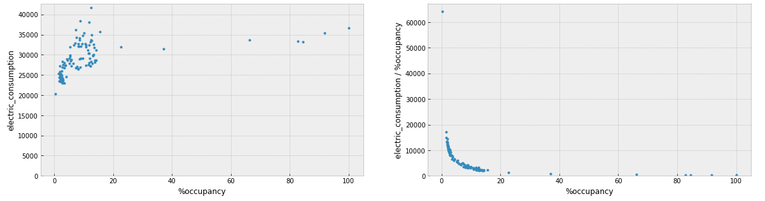

* **What Else, if anything, Can Be Constructed From Your Model?**

It seems tenant’s consumption does not have strong relation to building-wide consumption. Maybe this is because tenants only need to pay lights, small electronic equipment, and etc. electricity fees, while HVAC contributes large part of building consumption, and tenants don’t pay for this directly.

Building entries data starts from 2/10/2020. Covid-19 started to affect New Your City around Feb/Mar until now. People chose to work from home since then. That seems the biggest reason why entries decrease sharply.

* **What Other Information, if any, Would You Need to Better Your Model?**

Weather: sun, cloudy, rainy, extreme weather, …

Sunrise time, sunset time

Entries before 2/10/2020

Building HVAC consumption, lights consumption, other consumption

Tenant company category